Bociat Daniel-Tiberiu

1. Define mean, median and range

Mean = arithmetic mean of the data

Median = the **middle number**in a data set (position-wise not value-wise)

Range = the set of y-values that are output for the domain.

1. Define standard deviation and variance

Standard deviation is a measure of dispersement in statistics. “Dispersement” tells you how much your data is spread out. Specifically, it shows you how much your data is spread out around the [mean](https://www.statisticshowto.com/probability-and-statistics/statistics-definitions/mean-median-mode/#mean) or [average](https://www.statisticshowto.com/arithmetic-mean/).

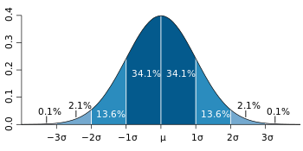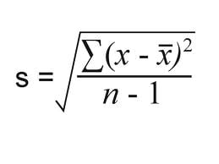

The variance is mathematically defined as **the**[**average**](https://calculushowto.com/average-value-of-a-function/#def)**of the squared differences from the mean**.

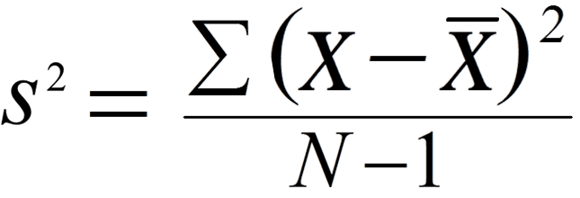 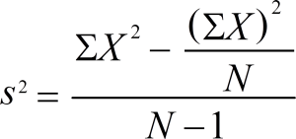

1. What is sample and what is population?

A [sample](https://www.statisticshowto.com/sample/)is a select number of items taken from a [population](https://www.statisticshowto.com/what-is-a-population/).

A population is a whole, it’s **every member of a group.** A population is the opposite to a [sample](https://www.statisticshowto.com/sample/), which is a fraction or percentage of a group

1. What is interquartile range?

The **interquartile range** is a measure of where the “[middle fifty](https://www.statisticshowto.com/middle-fifty/)” is in a data set.

The interquartile range formula is the first [quartile](https://www.statisticshowto.com/what-are-quartiles/)subtracted from the third [quartile](https://www.statisticshowto.com/what-are-quartiles/):

**IQR = Q3 – Q1.**

Think of Q1 as a median in the lower half of the data and think of Q3 as a median for the upper half of data.

1. What is histogram?

Histograms are similar to [bar charts](https://www.statisticshowto.com/probability-and-statistics/descriptive-statistics/bar-chart-bar-graph-examples/); they are a way to display counts of data. A bar graph charts actual counts against categories; The height of the bar indicates the number of items in that category. A histogram displays the same [categorical variables](https://www.statisticshowto.com/what-is-a-categorical-variable/) in “bins”.

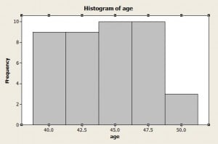

1. What is bias in statistics?

Bias is the tendency of a statistic to [**overestimate**](http://www.merriam-webster.com/dictionary/overestimate) or [**underestimate**](http://www.merriam-webster.com/dictionary/underestimate) a parameter.

Bias can seep into your results for a slew of reasons including sampling or measurement errors, or [unrepresentative samples](https://www.statisticshowto.com/representative-sample/).

1. What is a statistical distribution? What is the most common one?

The distribution of a variable is a description of the relative numbers of times each possible outcome will occur in a number of trials. The function describing the probability that a given value will occur is called the [probability density function](https://mathworld.wolfram.com/ProbabilityDensityFunction.html) (abbreviated PDF), and the function describing the cumulative probability that a given value *or any value smaller than it* will occur is called the [distribution function](https://mathworld.wolfram.com/DistributionFunction.html) (or cumulative distribution function, abbreviated CDF).

The most common distribution is the [normal distribution](https://www.statisticshowto.com/probability-and-statistics/normal-distributions/).

1. What is the difference between discrete and continous distribution?

A discrete distribution is one in which the data can only take on certain values, for example integers.

A continuous distribution is one in which data can take on any value within a specified range (which may be infinite), for example a point on a segment.